## Basics

* operating System

### History

Ken Thompson early 70s UNIX

MULTICS

UNICS

UNIX

UNIX 1975

system V

Linus Torvalds early 90s Linux

Richard Stallman

Next – Darwin

### Open source

1. sell the ice cream , hide recipe
2. sell the ice cream, recipe public
3. free ice cream on sunday, hide the recipe
4. free ice cream on sunday, recipe public

source code open

firefox

VLC

GIMP

Blender

Audacity

Wordpress

Linux

### standards

sysV

BSD

### Unix based systems

Darwin

Solaris

AIX

HP-UX

Xenix

FreeBSD

### Linux based systems

kernel

GNU open source

Red Hat Linux 1994

Linux Mint

Fedora Core

OpenSuse

Debian Linux

Elementary OS

Kali Linux

Ubuntu Linux

BOSS

unix-like & Linux

## architecture

### kernel

* process management
  + creation
  + scheduling
  + termination
* memory management
  + allocation
* device drivers
  + communication between OS & hardware
* systems calls
  + user applications & kernel interactions

### system library

* special functions
* applications use to perform system-related tasks
* glibc

### system utilities

ls

cp

grep

ifconfig

top

### user applications

web browsers

office suites

text editors

games

### shell

cli

### File system structure

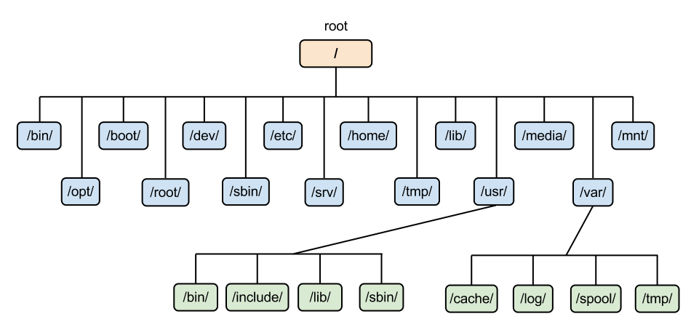

inverted tree structure

/ <root>

/bin

/home/john

/bin essential command binaries

/etc configuration files

/home user home directories

/lib essential shared libraries & kernel modules

/usr user utilities & applications

/var variable data files (logs, databases etc)

/dev device driver files

### Bootloader

GRUB

LILO

## shell

terminal

command line interpreter

CLI

### types

sh

ksh

csh tcsh

zsh

Fish

bash

### prompt

username@hostname ~ $

$ regular user

# root user

### command (structure)

ls

ls -l

ls -l /home/john/Desktop

command options arguments

command arguments options

## basic commands

ls

-l long listing

more info

-a all

clear

cleared the screen

pwd

print working directory

date

cal

bc

cd

### help

#### whatis

#### man

man ls

b

f

search

/sss searches for text sss within the man page

n next

shift + n previous

pages

1 commands

2 system calls

3 library calls (functions)

printf() exit()

4 special files

usually /dev

5 file formats & conventions

6 games

7 misc

signals

8 system admin

#### help

## files and directories

### commands

cd

.. parent

cd ..

<name>

cd john